Web Service Practical

Name: Nur Aina Farisha binti Muhmad Jaffar

Matric No.: 196488

1. Result for addValues

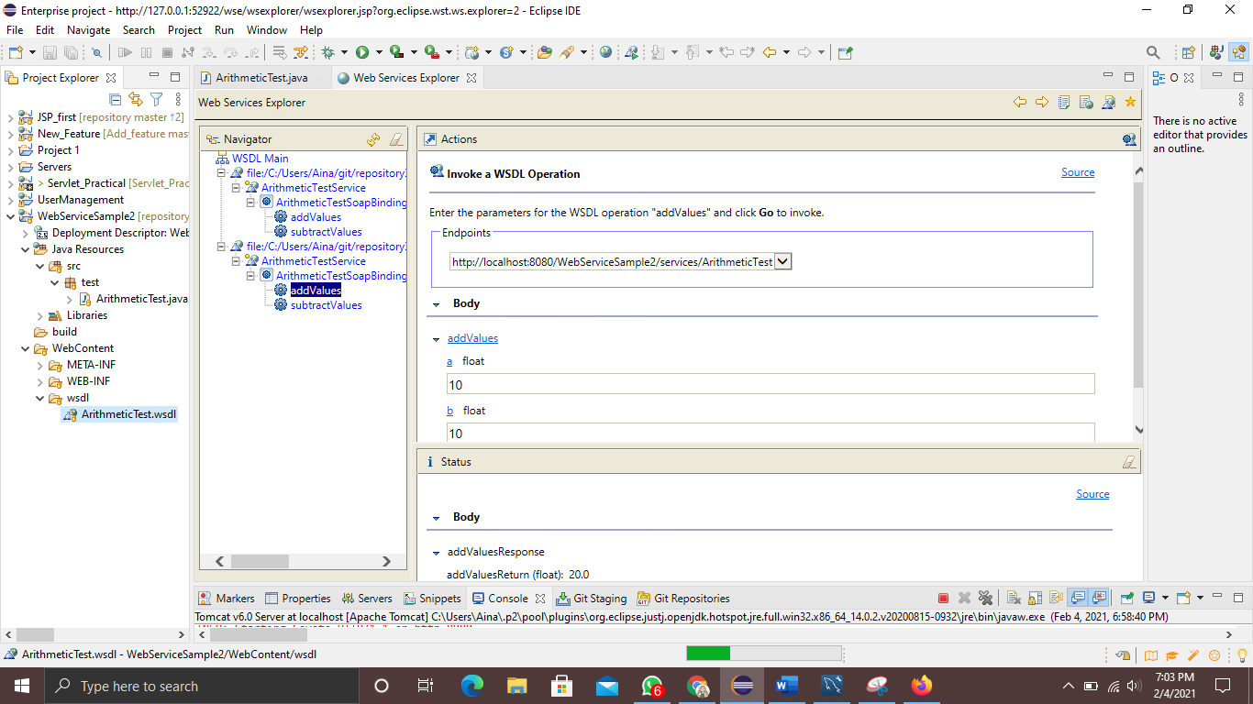

1. Result for subtractValues

